Team 11  
 Janwillem te Voortwis  
 Raoul Fasel  
 Mitchell Verlinden  
 Wouter Westerdijk

<http://raoulfasel.github.io/DataVizGroup/groupdata/> < Interactive visualization

<https://drive.google.com/file/d/0B0Dp_gRqddNSUDEyOHl6Um1xZzA/view?usp=sharing> < Tableau

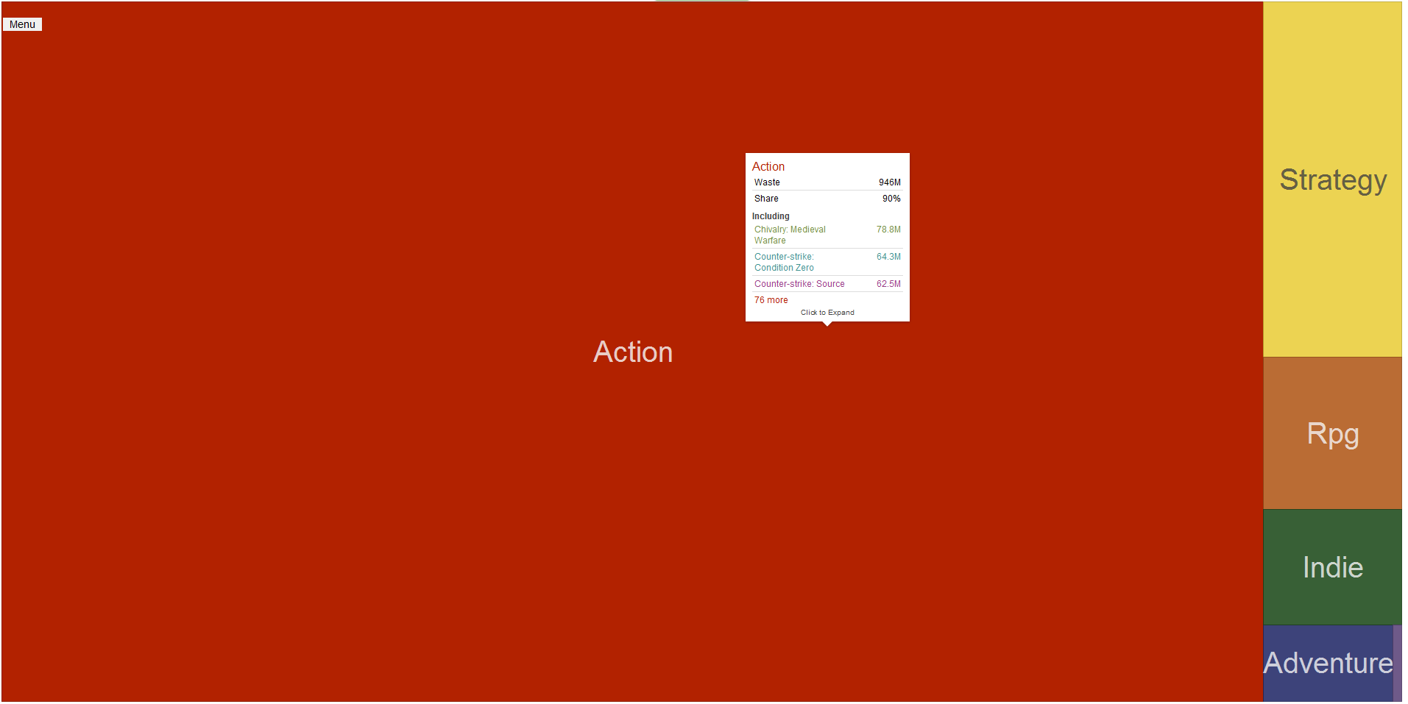

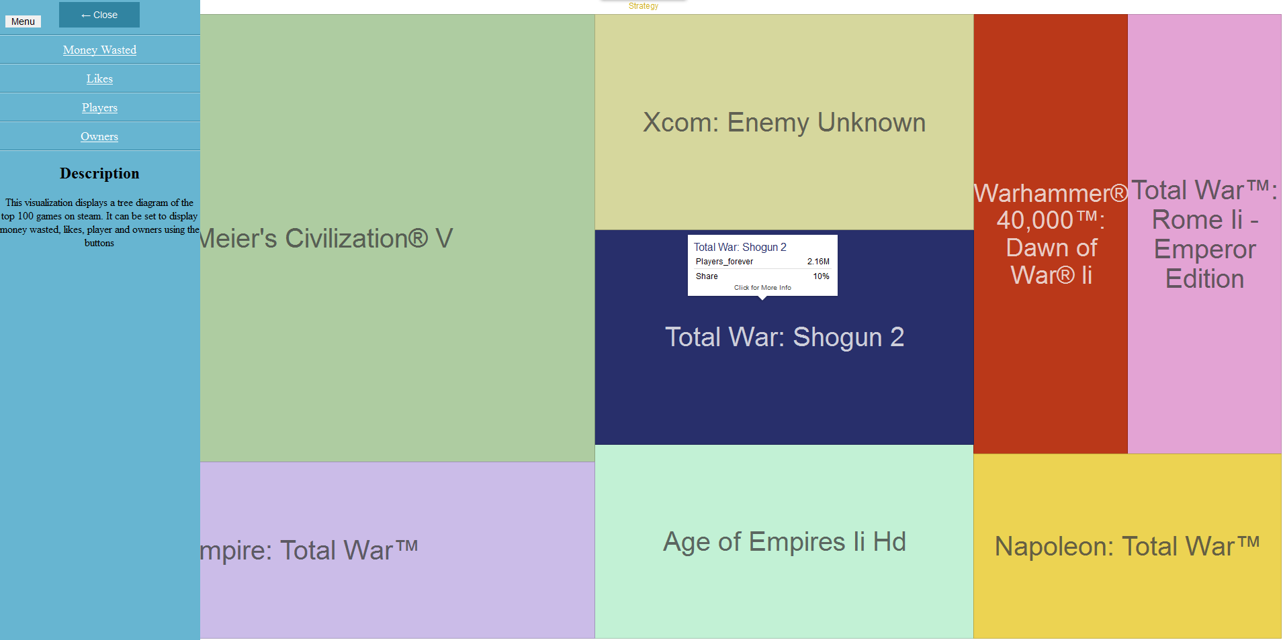

Explanation visualization I:  
Tree map of the top 100 games on Steam. The tree map gives four different insights: ‘Money Wasted’, ‘Likes’, ‘Players’, and ‘Owners’. First it is ordered by genre, the viewer can click on one of the shown genres to see the games in that genre. Then the viewer can even click on a single game to view every detail about the game (which is not visualized, but it is only for extra information): 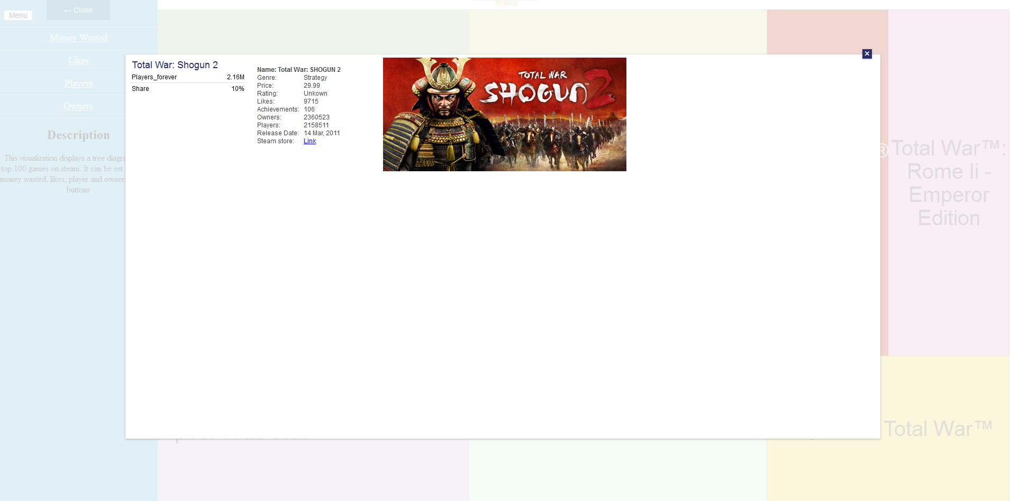

Explanation visualization II:  
Seven different visualizations about possible correlations between aspects of the games in the Steam top 100.

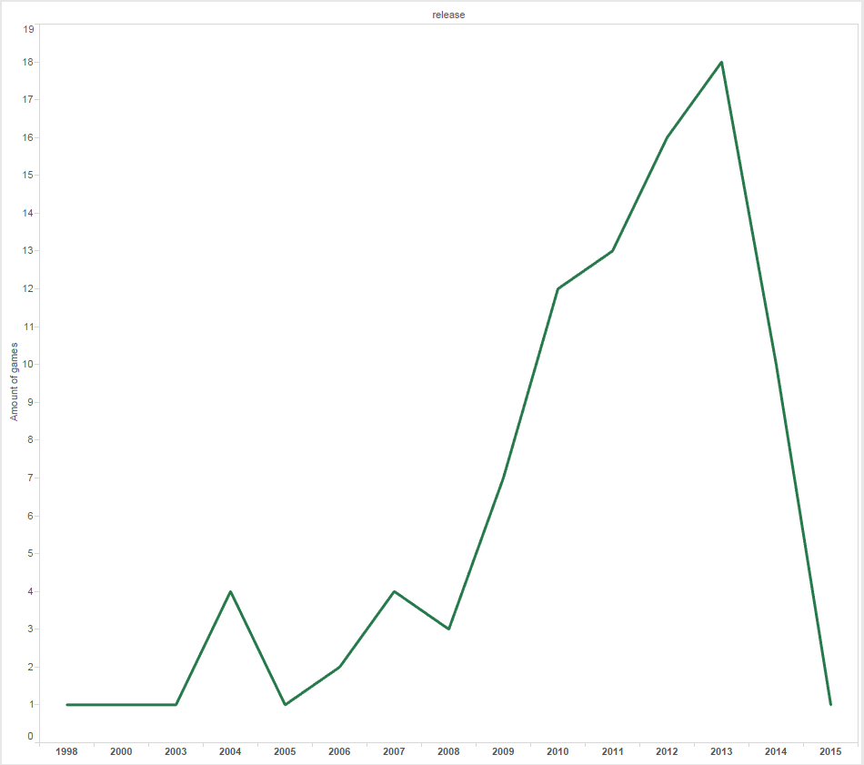  
I: The amount of games in the top 100 per year. Most games are from 2009-2013.

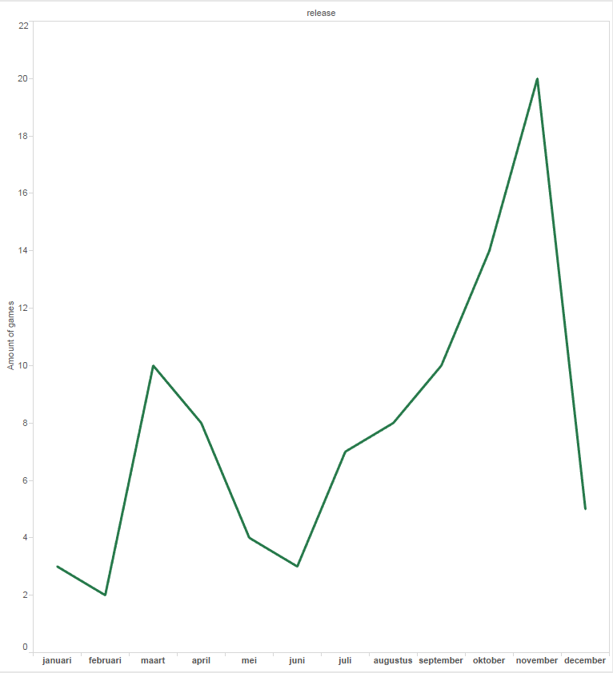  
II: The amount of games in the top 100 per month. There are two peaks with most games released. Apparently, fall is the most popular game release season.

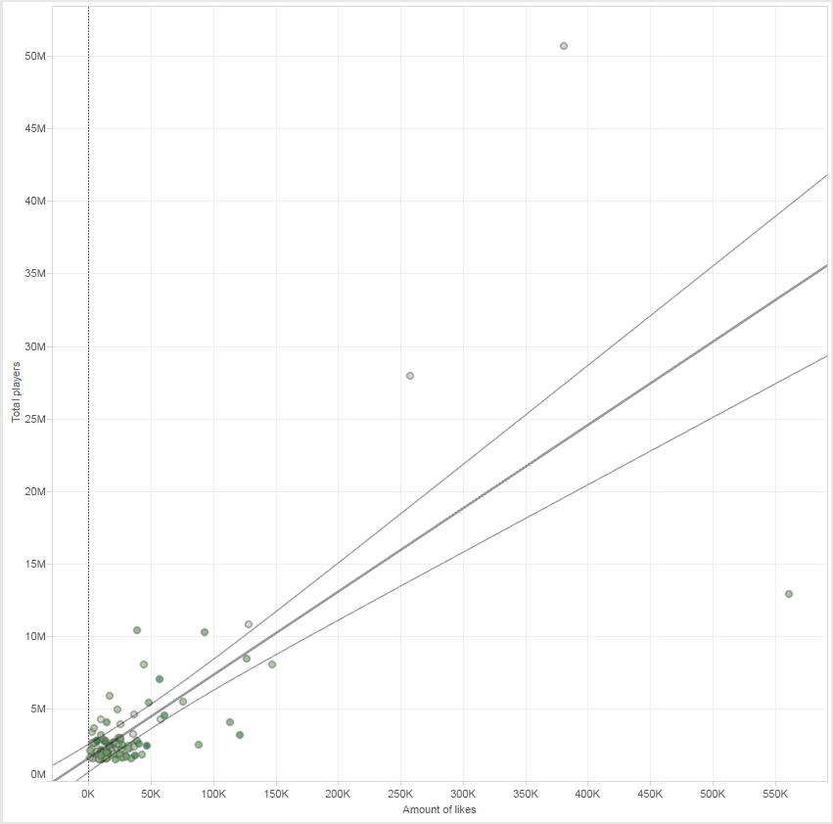  
III: Possible correlation between the total players of a game and its likes. There seems to be a correlation, which could be explained: the more players, the more popular the games becomes, thus more people will like the game.

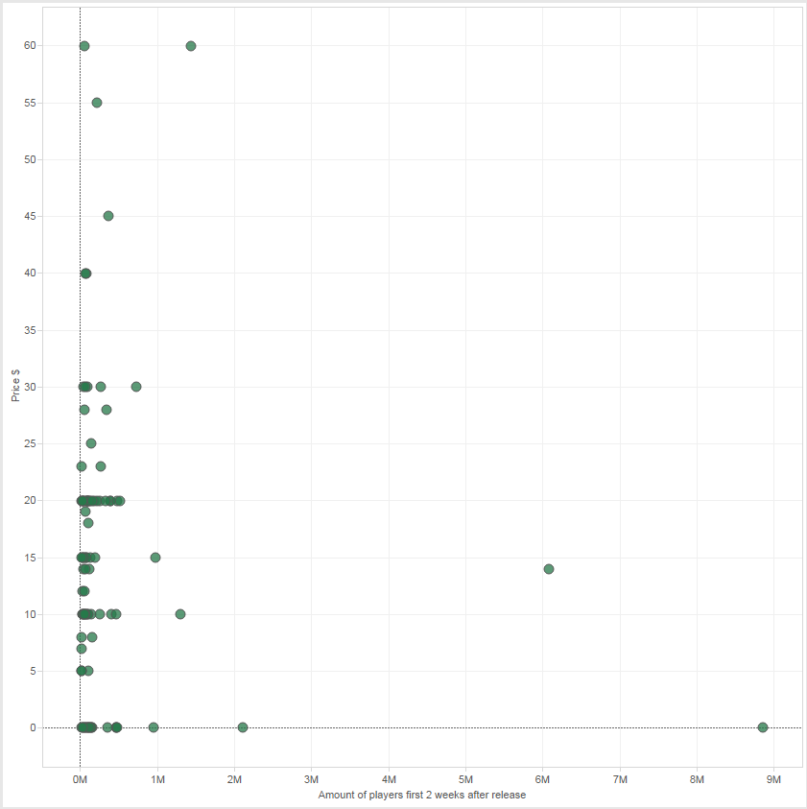  
IV: Possible correlation between the price of a game and its amount of players in the two weeks after its release. The hypothesis was that the more expensive a game would be, the more people would directly play it, but there seems to be no correlation.

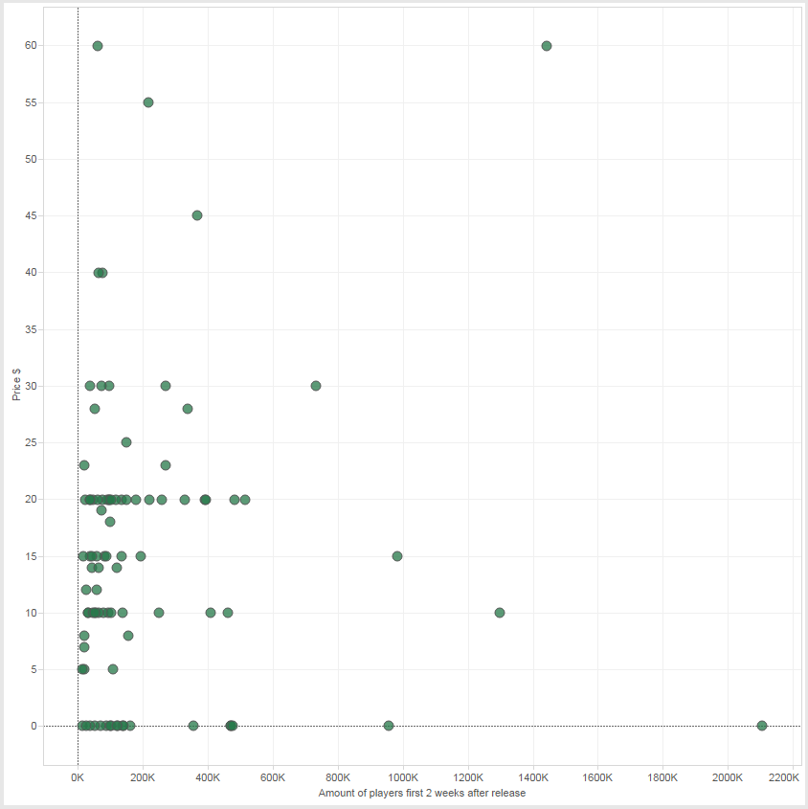  
V: Same as IV, but the two outliers of amount of players are excluded to provide a better view on the other games.

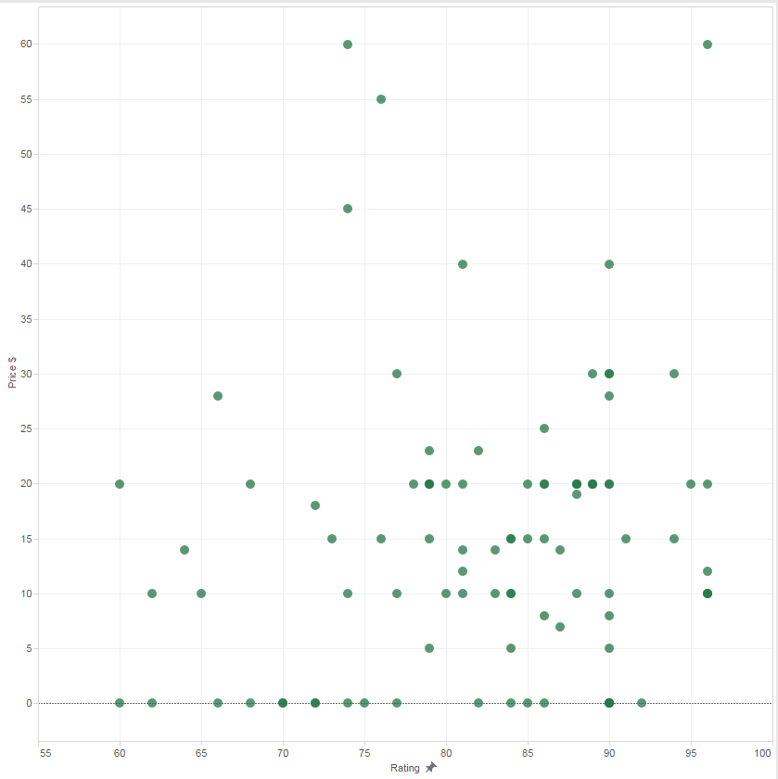  
VI: Possible correlation between price and rating. Hypothesis: a better rated game will be more expensive. There seems to be no correlation.

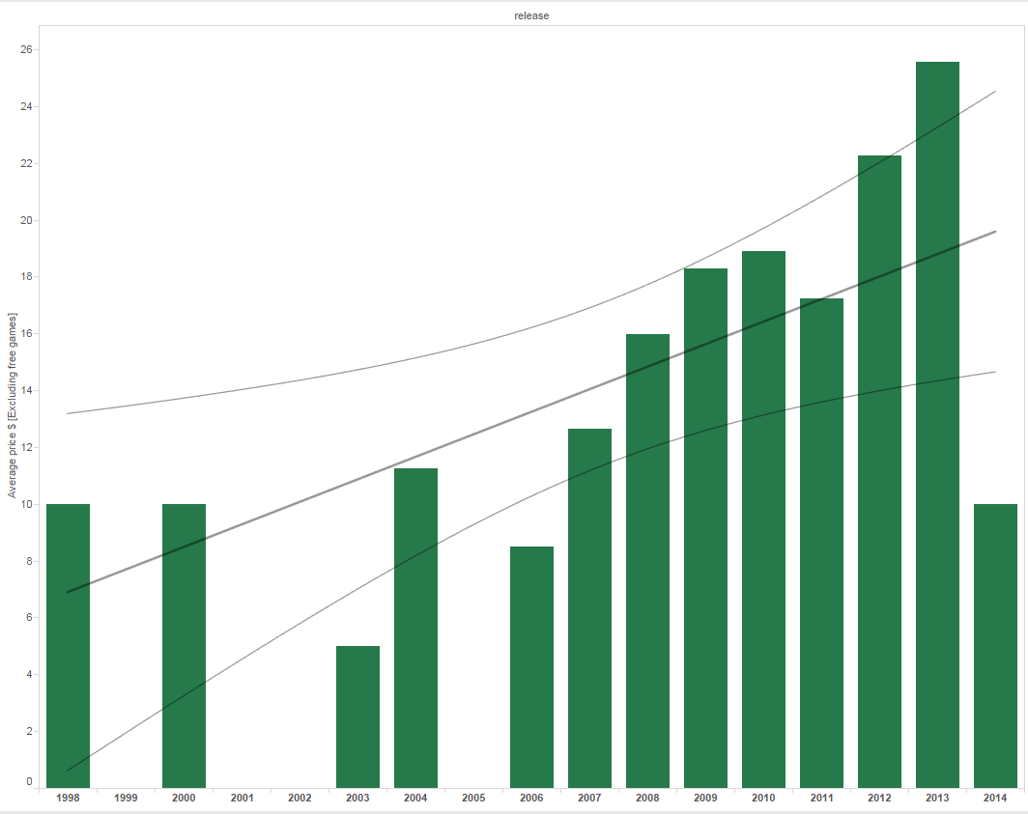  
VII: Are games getting more expensive over the years? This visualization would’ve been better with every game included, not just the Steam top 100. 2015 is excluded, because there was only one game. There seems to be an increasing trend.

Data variables:  
*name, price, genre, metacritic (rating), release date, likes, achievements, linux, mac, windows, players_forever, players_2weeks*  
Name is used to distinguish the games (detail)  
Price is used as position on the Y-axis and at vis II.III as colour coding  
Genre is used as group, to separate games in visualization I  
Rating is used as position on X-axis at vis II.VI  
Release date is used as position (time-line) on X-axis at vis II.I & II.II  
Likes is used as size at vis I and as position on X-axis at vis II.III  
Achievements has not been used  
Linux, mac, windows has not been used  
Players_forever is used as size at vis I and as position on Y-axis at vis II.III  
Players_2weeks is used as position on X-axis at vis II.IV and vis II.V

Data source:

<http://store.steampowered.com/stats/>   
<http://steamspy.com/api.php>   
<http://steamspy.com/api.php?request=all>  
<http://steamspy.com/api.php?request=top100forever>   
<http://store.steampowered.com/api/appdetails/?appids=XXX> (where XXX is the Steam ID of the game)

Tools:  
D3+ Library for visualization I  
Tableau for visualization II

We didn’t use any existing materials.